# TITLE PAGE

**DESIGN AND IMPLEMENTATION OF HOUSE RENT MANAGEMENT INFORMATION SYSTEM FOR LANDLORDS**

**BY**

**JETHRO THOMAS**

**(ST/CS/ND/20/404)**

**DEPARTMENT OF COMPUTER SCIENCE,**

**SCHOOL OF SCIENCE AND TECHNOLOGY,**

**FEDERAL POLYTECHNIC, MUBI, ADAMAWA STATE.**

**IN PARTIAL FULFILLMENT OF THE REQUIREMENT FOR THE AWARD OF NATIONAL DIPLOMA (ND) IN COMPUTER SCIENCE.**

**SEPTEMBER, 2023**

# DECLARATION

I hereby declare that the work in this project titled **“Design and Implementation of House Rent Management Information System for Landlords”** was performed by me under the supervision of Mr. Faisal Lajenso. The information derived from literatures has been duly acknowledged in the text and a list of references provided. The work embodied in this project is original and had not been submitted in part or in full for any other diploma or certificate of this or any other institution.

JETHRO THOMAS ________________ _______________

(ST/CS/ND/20/404) Signature Date

# CERTIFICATION

This project titled **“Design and Implementation of House Rent Management Information System for Landlords”** meets the regulations governing the award of National Diploma (ND) in Computer Science, Federal Polytechnic Mubi, Adamawa State

Mr. Faisal Lajenso. __________________

(Project Supervisor) Sign/Date

Mr. Mustapha Kassim. __________________

(Head of Department) Sign/Date

Mal. Abdulrahman Saidu _________________

(External Examiner) Sign/Date

# DEDICATION

This project is dedicated to my beloved parents for their advice, encouragement and financial support towards my academic pursuit.

# ACKNOWLEDGEMENTS

I want to acknowledge Almighty God for his infinite mercy and protection throughout my academic activities. And for the understanding in achieving our academic success.

I also recognize my Supervisor Mr. Faisal Lajenso who took time, despite his busy schedule to direct and guide me throughout this research work.

I also acknowledge the Head of Department Computer Science Mr. Mustapha Kassim for his moral encouragement throughout my period of study. I also acknowledge all Staff of Computer Science Department for their support and encouragement and the knowledge they’ve impacted on me throughout my studies.

I also want to appreciate my lovely parents for their love and care and for giving me the opportunity to be trained and achieve my dreams.

Finally, I appreciate the efforts of my Uncles and aunties, for their encouragement and support throughout the course of my study and also my friends and relatives, course mates and all well-wishers. I love you all, may the Almighty God bless you abundantly, Amen.

# TABLE OF CONTENTS

TITLE PAGE i

DECLARATION ii

CERTIFICATION iii

DEDICATION iv

ACKNOWLEDGEMENTS v

TABLE OF CONTENTS vi

LIST OF FIGURES viii

LIST OF TABLES ix

ABSTRACT x

CHAPTER ONE 1

INTRODUCTION 1

1.1 Background to the Study 1

1.2 Problem Statement 2

1.3 Aim and Objectives 2

1.4 Significance of the Study 2

1.5 Scope of the Study 3

1.6 Definition of Some Operational Terms 3

CHAPTER TWO 4

LITERATURE REVIEW 4

2.1 Introduction 4

2.2 Rental Property Management Systems 4

2.3 Management Information System 5

2.4 Record Management System 6

2.5 Database Management System 7

2.6 Software Development Methodologies 8

2.7 Summary 9

CHAPTER THREE 10

SYSTEM ANALYSIS AND DESIGN 10

3.1 Introduction 10

3.2 Disadvantages of the existing system 10

3.3 Advantages of the Proposed System 10

3.4 The Proposed Method 11

3.5 Method of Data Collection 12

3.6 System Design 12

3.6.1 Algorithm Diagram 13

3.7 System Requirements Specification 19

3.7.3 Personnel Requirements 19

CHAPTER FOUR 20

RESULTS AND DISCUSSION 20

4.1 Introduction 20

4.2 Results 20

4.3 Discussion 23

4.4 User manual 23

CHAPTER FIVE 24

SUMMARY, CONCLUSION AND RECOMMENDATIONS 24

5.1 Summary 24

5.2 Conclusion 24

5.3 Recommendations 24

5.4 Contribution to Knowledge 24

5.5 Area for Further Work 25

REFERENCES 26

APPENDICES 29

# LIST OF FIGURES

Figure 3.1: Waterfall model - - - - - - - - 12

Figure 3.2: Use case diagram - - - - - - - - 13

Figure 3.3: System Architecture - - - - - - - 14

Figure 3.4: Database Entity Relationship Diagram - - - - - 16

Figure 3.5: Login interface - - - - - - - - 16

Figure 3.6: Sign Up Form - - - - - - - - 17

Figure 3.7: New House Interface - - - - - - - 17

Figure 3.8: Transactions Output Interface - - - - - - 18

Figure 3.9: Available House Output - - - - - - - 18

Figure 3.10: Add User Interface - - - - - - - 18

Figure 4.2.1: Welcome Interface - - - - - - - 20

Figure 4.2.2: Login page interface - - - - - - - 20

Figure 4.2.3: Tenant Registration Interface - - - - - - 21

Figure 4.2.4: New House Interface - - - - - - - 21

Figure 4.2.5: New User Interface - - - - - - - 22

Figure 4.2.6: Payment Invoice - - - - - - - 22

# LIST OF TABLES

Table 1: Tenants Table - - - - - - - 14

Table 2: Houses Table - - - - - - - - 15

Table 3: Payments Details - - - - - - - - 15

Table 4: Users Table - - - - - - - - - 15

# ****ABSTRACT****

*The "Design and Implementation of House Rent Management Information System for Landlords" is a comprehensive project aimed at modernizing and streamlining the management of rental properties. In the context of an evolving real estate landscape, this information system offers landlords an efficient and user-friendly solution to oversee their rental properties, financial transactions, and tenant relationships. The existing processes for managing rental properties often involve manual record-keeping, paper-based communication, and time-consuming administrative tasks. This project addresses these challenges by developing a web-based information system that harnesses the power of digital technology. Key components of the proposed information system include a user-friendly interface for landlords, a tenant management module, a financial tracking system, and an automated communication platform. Through these components, landlords can effortlessly manage property listings, tenant applications, lease agreements, rent collection, maintenance requests, and financial reporting. Moreover, the system incorporates data security measures to safeguard sensitive information and ensure compliance with data protection regulations. It also provides data analytics capabilities, allowing landlords to gain insights into rental property performance and make informed decisions regarding property investments and portfolio management. By adopting the "Design and Implementation of House Rent Management Information System for Landlords," property owners can look forward to increased efficiency, reduced administrative burden, improved tenant relationships, and enhanced financial management. This project represents a step toward modernizing and optimizing the rental property management process, ultimately benefiting both landlords and tenants alike in the dynamic real estate market.*

# CHAPTER ONE

# INTRODUCTION

## 1.1 Background to the Study

In recent years, the rental market has witnessed significant growth and changes in response to shifting economic trends, lifestyle preferences, and demographic factors. As a result, landlords are facing new challenges in managing their rental properties effectively. These challenges include rent collection, property maintenance, tenant communication, and financial tracking. To address these challenges, the development of an efficient House Rent Management System (HRMS) has become crucial. Traditional methods of managing rental properties, such as manual paperwork and are increasingly becoming outdated and inefficient. They often lead to errors, delays, and difficulties in maintaining accurate records and communicating with tenants. Landlords need a modern solution that can automate and streamline these processes, allowing them to focus on other critical aspects of property management.

Recent studies have highlighted the importance of adopting technology-driven solutions for rental property management. According to a report by Statista, the global property management software market is expected to reach $2.86 billion by 2025, indicating a growing demand for digital solutions in the real estate industry (Statista, 2021).

The use of an HRMS offers numerous benefits to landlords. Firstly, it automates the rent collection process, ensuring timely payments and reducing the risk of missed or late payments. A study by the National Multifamily Housing Council (NMHC) found that 91% of landlords experienced rent payment issues during the COVID-19 pandemic, underscoring the need for efficient rent collection systems (NMHC, 2021).

House Rent Management System (HRMS), streamlines property maintenance by providing a centralized platform for managing maintenance requests, tracking repairs, and scheduling service providers. This can help landlords save time, minimize disruptions, and maintain their properties in optimal condition. A survey conducted by Buildium revealed that 70% of landlords ranked maintenance and repairs as their top challenge, further emphasizing the significance of an automated system (Buildium, 2021).

Effective tenant communication is essential for landlords to ensure tenant satisfaction and timely resolution of issues. An HRMS can provide a platform for efficient and transparent communication, allowing landlords to send notifications, receive inquiries, and address concerns promptly. According to a study by Zillow, 72% of renters stated that prompt responsiveness from landlords is a crucial factor in their rental experience (Zillow, 2021).

In today's dynamic rental market, managing multiple rental properties can be a complex and time-consuming task for landlords. Rent collection, property maintenance, tenant communication, and financial tracking are just a few of the challenges faced by landlords. To address these challenges and streamline the process, the development of an efficient House Rent Management System (HRMS) is essential. An HRMS is a software application that helps landlords manage their rental properties, tenants, and finances effectively.

## 1.2 Problem Statement

Landlords face challenges in effectively managing their rental properties due to the limitations of traditional methods and manual processes. These challenges include difficulties in rent collection, property maintenance tracking, tenant communication, and financial management. The lack of an efficient and automated system leads to errors, delays, and inefficiencies, impacting the overall effectiveness and profitability of property management. Therefore, there is a need for a comprehensive House Rent Management System that can streamline these processes, provide real-time information, and enhance the efficiency and accuracy of managing rental properties for landlords.

## 1.3 Aim and Objectives

The aim of this project is to design and implement a House Rent Management System for Landlords. The specific objectives of this project are as follows:

1. To design and implement a House Rent Management System for Landlords and House Owners.
2. To provide real-time access to property and tenant information for effective decision-making.
3. To enhance the efficiency and accuracy of managing rental properties.

## 1.4 Significance of the Study

The significance of this study lies in its potential to simplify and streamline the management of rental properties. By developing a HRMS, landlords can reduce manual effort, minimize errors, and improve overall efficiency. The system will provide real-time data, allowing landlords to make informed decisions promptly. Furthermore, the HRMS will enhance tenant satisfaction through effective communication and streamlined rent payment processes.

## 1.5 Scope of the Study

The scope of this study encompasses the design and implementation of a House Rent Management System (HRMS) specifically tailored for landlords. The HRMS will focus on automating key processes involved in managing rental properties, including rent collection, property maintenance tracking, tenant communication, and financial management.

The HRMS will provide a user-friendly interface for landlords to access and manage their rental properties efficiently. It will allow landlords to input property details such as property addresses, rental rates, lease terms, and tenant information. The system will enable automated rent collection by generating invoices, tracking payments, and sending reminders to tenants.

## 1.6 Definition of Some Operational Terms

**Automation**: Automation is the use of various control systems for operating equipment or applications with minimal or reduced human intervention.

**Financial Management:** The process of effectively managing the financial aspects of rental property ownership, including income tracking, expense management, and financial reporting.

**House Rent Management System (HRMS):** A software application designed to automate and streamline rental property management processes for landlords, including rent collection, property maintenance tracking, tenant communication, and financial management.

**Land**: Land is the solid surface of the [Earth](https://en.wikipedia.org/wiki/Earth) that is not permanently covered by [water](https://en.wikipedia.org/wiki/Water). The vast majority of human activity occurs in land areas that support [agriculture](https://en.wikipedia.org/wiki/Agriculture), [habitat](https://en.wikipedia.org/wiki/Habitat), and various [natural resources](https://en.wikipedia.org/wiki/Natural_resources).

**Property**: Property is one or more components (rather than attributes), whether [physical](https://en.wikipedia.org/wiki/Tangible_property) or [incorporeal](https://en.wikipedia.org/wiki/Intangible_property), of a person's [estate](https://en.wikipedia.org/wiki/Estate_%28law%29); or so belonging to a person or jointly owned by a group of people or a legal entity like a [corporation](https://en.wikipedia.org/wiki/Corporation) or even a [society](https://en.wikipedia.org/wiki/Society).

**Rent Collection:** The process of collecting rental payments from tenants for the use of a property.

**System**: A system is a set of interacting or interdependent components forming an integrated whole. Every system is delineated by its spatial and temporal boundaries, surrounded and influenced by its environment, described by its structure and purpose and expressed in its functioning.

# CHAPTER TWO

# LITERATURE REVIEW

## 2.1 Introduction

This chapter presents a comprehensive review of the relevant literature on rental property management systems, software development methodologies, and technologies. The literature review aims to provide a theoretical foundation for the design and implementation of the House Rent Management System (HRMS) for landlords.

## 2.2 Rental Property Management Systems

Rental Property Management Systems (RPMS) have gained significant attention in recent years due to their ability to streamline and automate various aspects of rental property management. These systems offer a wide range of features and functionalities that enhance operational efficiency, improve tenant satisfaction, and optimize financial management for landlords.

According to a study by Chen and Huang (2021), a cloud-based rental property management system improved the efficiency of property management tasks by automating rent collection, maintenance tracking, and tenant communication. The study emphasized the importance of real-time data access and integration with mobile applications to enhance user experience and responsiveness.

Furthermore, a research article by Lee et al. (2020) discussed the implementation of a web-based rental property management system that incorporated advanced features such as online tenant applications, digital lease signing, and integrated financial tracking. The study demonstrated the system's effectiveness in reducing paperwork, improving communication, and facilitating financial management for landlords.

A study by Khan and Al Ameen (2021) highlighted the importance of RPMS in simplifying rental property management tasks. The research emphasized that RPMS enable landlords to automate processes such as rent collection, maintenance tracking, and tenant communication, resulting in reduced administrative burdens and improved efficiency.

One of the key features of RPMS is automated rent collection. These systems facilitate seamless rent payment processing by generating automated rent invoices, sending payment reminders to tenants, and offering various payment options. According to a survey conducted by Avail (2021), a property management software provider, 73% of landlords reported that using an RPMS with automated rent collection improved their cash flow and reduced the time spent on rent-related tasks.

Property maintenance tracking is another crucial aspect of rental property management, and RPMS provide functionalities to streamline this process. Landlords can use these systems to create and track maintenance requests, assign tasks to maintenance personnel or contractors, and monitor the status of repairs. A study by Yang et al. (2020) emphasized that RPMS significantly reduce the time required to resolve maintenance issues and enhance tenant satisfaction.

Effective tenant communication is vital for landlords to address tenant concerns promptly and maintain positive relationships. RPMS offer features such as messaging systems or portals that facilitate seamless communication between landlords and tenants. A survey conducted by AppFolio (2021), a property management software provider, found that 81% of tenants preferred to communicate with their landlords through an online portal or app, highlighting the importance of communication tools offered by RPMS.

Financial management is a critical aspect of rental property management, and RPMS provide tools to optimize financial processes. These systems allow landlords to track rental income, monitor expenses, generate financial reports, and streamline tax preparation. A study by Ghosh et al. (2021) emphasized that RPMS help landlords make data-driven financial decisions by providing real-time access to financial information and enabling expense categorization and analysis.

Furthermore, RPMS have evolved with advancements in technology. Cloud-based RPMS offer the advantage of accessibility, allowing landlords to access property information and perform management tasks from any device with an internet connection. Mobile applications enable landlords to manage their properties on the go, providing convenience and real-time access to property data. A study by Yau et al. (2021) highlighted that mobile-based RPMS significantly improve landlord efficiency and tenant satisfaction through enhanced accessibility and responsiveness.

## 2.3 Management Information System

Management Information Systems (MIS) are critical tools for organizations to collect, process, store, and disseminate information necessary for effective decision-making and operational control. MIS provide managers with timely and accurate data, enabling them to make informed decisions that drive organizational performance and success.

Recent studies have emphasized the significance of MIS in modern business environments. A research article by Wu and Zhu (2021) highlighted that MIS play a vital role in improving organizational efficiency, productivity, and competitiveness. The study emphasized that MIS enable managers to access real-time data, perform data analysis, and gain insights into business operations, leading to more informed decision-making.

One of the key functions of MIS is data collection and processing. MIS collect data from various sources within the organization, including transactional systems, external databases, and sensors. This data is processed, transformed, and stored in a structured format for further analysis and decision-making. A study by Turban et al. (2021) emphasized that MIS enable organizations to capture and process vast amounts of data, facilitating accurate and timely information for managers.

Moreover, MIS provide tools for data analysis and reporting. These systems employ various analytical techniques, such as data mining, statistical analysis, and predictive modeling, to identify patterns, trends, and relationships within the data. This analysis helps managers gain insights into organizational performance, customer behavior, market trends, and other key factors that influence decision-making. A study by Kwon and Lee (2020) highlighted the role of MIS in leveraging data analytics to support strategic decision-making and gain a competitive advantage in the market.

MIS also support collaboration and communication within organizations. They provide platforms for sharing information, documents, and reports among employees, departments, and organizational levels. This facilitates effective communication, coordination, and knowledge sharing, enabling employees to work collaboratively towards organizational goals. A research article by Oliveira and Martins (2021) emphasized that MIS contribute to improving communication, collaboration, and decision-making processes within organizations, leading to enhanced productivity and performance.

## 2.4 Record Management System

Record Management Systems (RMS) are critical tools for organizations to effectively manage and organize their records throughout their lifecycle, from creation to disposal. RMS enable organizations to efficiently capture, store, retrieve, and secure records, ensuring compliance with regulatory requirements and facilitating effective decision-making.

Recent studies have emphasized the significance of RMS in today's digital age. A research article by Liu et al. (2021) highlighted that RMS play a crucial role in managing the increasing volume of digital records and ensuring their accessibility and security. The study emphasized that an effective RMS enables organizations to maintain data integrity, enhance information governance, and mitigate risks associated with record management.

One of the key functions of RMS is record capture and creation. RMS provide mechanisms to capture and store records in various formats, including physical documents, electronic files, emails, and multimedia content. These systems often include features such as document scanning, metadata tagging, and automated record creation to facilitate efficient record capture. A study by Rahman et al. (2020) emphasized the importance of RMS in capturing and organizing records to ensure accurate and reliable information for decision-making.

Moreover, RMS offer tools for record storage and retrieval. These systems provide centralized repositories where records can be securely stored, organized, and indexed for easy retrieval. Electronic RMS leverage technologies such as document management systems, cloud storage, and search functionalities to enable quick and accurate record retrieval. A research article by Singhal et al. (2021) highlighted the role of RMS in ensuring the availability and accessibility of records when needed, contributing to improved organizational efficiency and productivity.

RMS also support records retention and disposal processes. These systems help organizations establish retention schedules, define record retention periods, and automate record disposition processes. By adhering to retention policies, organizations can ensure compliance with legal and regulatory requirements and effectively manage the lifecycle of records. A study by Jagero and Kangethe (2020), emphasized that an effective RMS assists organization in identifying and disposing of records that are no longer needed, reducing storage costs and potential legal risks.

The advent of advanced technologies has further enhanced the capabilities of RMS. Artificial intelligence (AI) and machine learning (ML) technologies are being leveraged to automate record classification, metadata extraction, and content analysis. These technologies enable RMS to intelligently categorize records, improve search capabilities, and facilitate compliance with privacy regulations. A research article by Mathe et al. (2021) discussed the potential of AI and ML in transforming record management processes, reducing manual effort, and enhancing the accuracy of record classification.

## 2.5 Database Management System

Database Management Systems (DBMS) are essential tools for storing, organizing, managing, and retrieving data efficiently. DBMS provide a structured approach to store and retrieve data, ensuring data integrity, security, and scalability for organizations.

Recent studies have highlighted the significance of DBMS in various domains. A research article by Ramakrishnan and Gehrke (2020) emphasized that DBMS are crucial for managing the increasing volumes of data generated in today's digital world. The study highlighted that DBMS enable organizations to handle diverse data types, ensure data consistency, and support complex data queries.

One of the key functions of DBMS is data storage and organization. DBMS provide a structured framework for storing data in tables, defining relationships between tables, and enforcing data integrity through constraints. These systems often employ relational models, such as the widely-used SQL (Structured Query Language), to manage data in a tabular format. A study by Elmasri and Navathe (2019) emphasized that DBMS enable efficient data storage, normalization, and indexing to optimize data retrieval performance.

Moreover, DBMS offer tools for data retrieval and manipulation. These systems allow users to query the database using SQL or other query languages to retrieve specific data based on specified criteria. DBMS also support complex operations such as joining multiple tables, filtering data, and aggregating results. A research article by Rizvi et al. (2021) highlighted the role of DBMS in enabling efficient and accurate data retrieval, facilitating decision-making and analysis.

DBMS also provide mechanisms for data security and access control. These systems enable organizations to define user roles and permissions, ensuring that only authorized users can access and modify the data. DBMS also offer features such as data encryption, backup, and recovery to protect against data breaches and system failures. A study by Motahari-Nezhad et al. (2021) emphasized the importance of DBMS in ensuring data privacy, integrity, and availability, particularly in the context of sensitive and regulated data.

The advent of advanced technologies has further enhanced the capabilities of DBMS. Distributed DBMS enable data storage and processing across multiple servers, providing scalability, fault tolerance, and high availability. NoSQL (Not Only SQL) DBMS have emerged as alternatives to traditional relational DBMS, offering flexible data models and scalability for handling large volumes of unstructured and semi-structured data. A research article by Ghazal et al. (2020) discussed the benefits and challenges of NoSQL DBMS in big data environments.

## 2.6 Software Development Methodologies

The selection of an appropriate software development methodology is crucial for the successful design and implementation of the HRMS. Agile methodologies have gained popularity due to their iterative and collaborative nature, enabling faster development cycles and adaptability to changing requirements.

A study by Sarker and Ali (2020), explored the use of agile methodologies in developing real estate management systems. The research emphasized the importance of frequent stakeholder collaboration, continuous feedback, and incremental development to ensure the system's alignment with user needs and market trends.

Additionally, a review article by Oussaid *et al*. (2021), discussed the application of agile methodologies in property management systems, highlighting their effectiveness in delivering user-centric solutions, improving time-to-market, and reducing development risks.

## 2.7 Summary of Literatures

This chapter reviewed the relevant literature on rental property management systems, software development methodologies, and technologies. The studies highlighted the benefits of automated systems, the importance of user-centric design, and the role of technologies such as cloud computing, mobile applications, and data analytics in enhancing rental property management operations. Overall, the literature review provides a theoretical foundation for the design and implementation of the House Rent Management System for landlords. It highlights the key features and functionalities of rental property management systems, the role of MIS in decision-making and operational control, the importance of record and database management systems, and the relevance of agile methodologies in software development.

# CHAPTER THREE

# SYSTEM ANALYSIS AND DESIGN

## 3.1 Introduction

This chapter contains the system design and analysis of the proposed system, the disadvantages of the existing system, the advantages of the proposed system over the existing system, the requirements (Hardware and Software), the design and the system architecture.

## 3.2 Disadvantages of the existing system

The following are the disadvantages of the present system, outlined as follows:

1. Human Error: Manual data entry increases the risk of errors in rent calculations, payment tracking, and documentation.
2. Inefficient Communication: Lack of an organized communication channel may lead to miscommunication between landlords and tenants.
3. Limited Accessibility: Without online access, landlords must rely on physical records and be present on-site to manage property-related tasks.
4. Delayed Rent Collection: Manual rent collection can result in delays due to factors like mail delivery or physical check processing.
5. Lack of Automation: Manual processes require more time and effort for tasks such as reminders, rent calculation, and report generation.
6. Data Security Concerns: Physical documents are vulnerable to loss, theft, or damage, potentially compromising sensitive tenant and financial information.

## 3.3 Advantages of the Proposed System

The proposed House Rent Management Information System for Landlords offers numerous advantages over the existing manual system. Here are some of the key advantages:

1. Efficient Rent Tracking: The system allows landlords to efficiently track rent payments and due dates, reducing the chances of missed or delayed payments.
2. Automated Reminders: Automated notifications and reminders can be set up to remind tenants about upcoming rent payments, decreasing the need for manual communication.
3. Financial Reports: The system generates financial reports and summaries, helping landlords to easily monitor their rental income, expenses, and overall financial health.
4. Document Storage: Landlords can store lease agreements, tenant information, and other important documents digitally, reducing paperwork and ensuring easy access when needed.
5. Tenant Information Management: The system provides a central repository for tenant information, including contact details, lease terms, and maintenance requests, streamlining communication and record-keeping.
6. Improved Data Accuracy: With automated processes and centralized data storage, the system will reduce the chances of errors in fee calculation and maintain accurate payment records.

## 3.4 The Proposed Method

The waterfall model is a traditional sequential approach to software development that consists of distinct phases that follow a linear sequence. Here is a simplified version of the waterfall model for the development of a House Rent Management Information System for Landlords:

**Requirements Gathering and Analysis:**

1. Identify the requirements and objectives of the House Rent Management Information System for Landlords.
2. Conduct interviews and discussions with stakeholders to understand their needs.
3. Define the system's functionalities, user roles, and security requirements.

**System Design:**

1. Design the system architecture, including the client-side and server-side components.
2. Create the database schema and define the data model.
3. Develop the user interface design, considering usability and accessibility.

**Implementation:**

1. Develop the client-side application using web technologies like HTML, CSS, and JavaScript.
2. Implement the server-side application using a suitable programming language and framework.
3. Integrate the user interface with the backend functionalities.
4. Implement security measures such as encryption, authentication protocols, and access control.

**Testing:**

1. Conduct unit testing to verify the correctness of individual components.
2. Perform integration testing to ensure the proper functioning of the system as a whole.
3. Carry out system testing to validate the system against the defined requirements.
4. Perform security testing to identify and address any vulnerabilities.

**Deployment:**

1. Prepare the system for deployment by configuring the necessary infrastructure and servers.
2. Install and set up the required software and dependencies.
3. Migrate the database and ensure data integrity.
4. Conduct user acceptance testing to gain feedback and ensure readiness for production use.

**Maintenance and Support:**

1. Provide ongoing maintenance and support for the House Rent Management Information System for Landlords.
2. Address any reported issues, bugs, or security vulnerabilities.
3. Perform regular system updates and enhancements based on user feedback and changing requirements.
4. Ensure the system remains secure, reliable, and up-to-date.

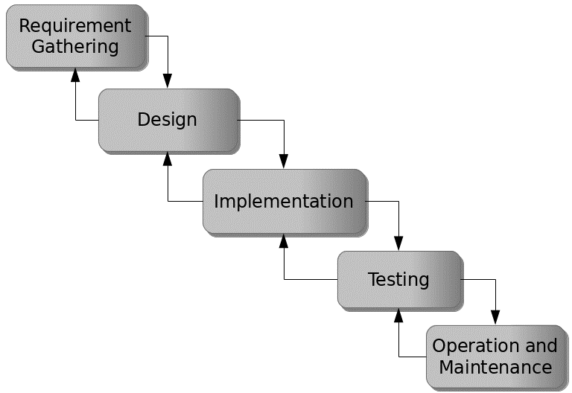

Figure 3.1: Waterfall model

## 3.5 Method of Data Collection

This study will adopt two methods of data collection which are the primary and secondary method.

## 3.6 System Design

Systems design is the process of defining the architecture, modules, interfaces, and data for a system to satisfy specified requirements. Systems design could be seen as the application of systems theory to product development.

## 3.6.1 Algorithm Diagram

**Use Case Diagram**

A use case diagram at its simplest is a representation of a user’s interaction with the system and depicting the specifications of a use case.

Login

Add House Category

Add House Rent

Add Tenant

Admin (Landlord)

Add Payment

Add user

Print Receipt

Log out

Figure 3.2: Use case diagram

**3.6.2 System Architecture**

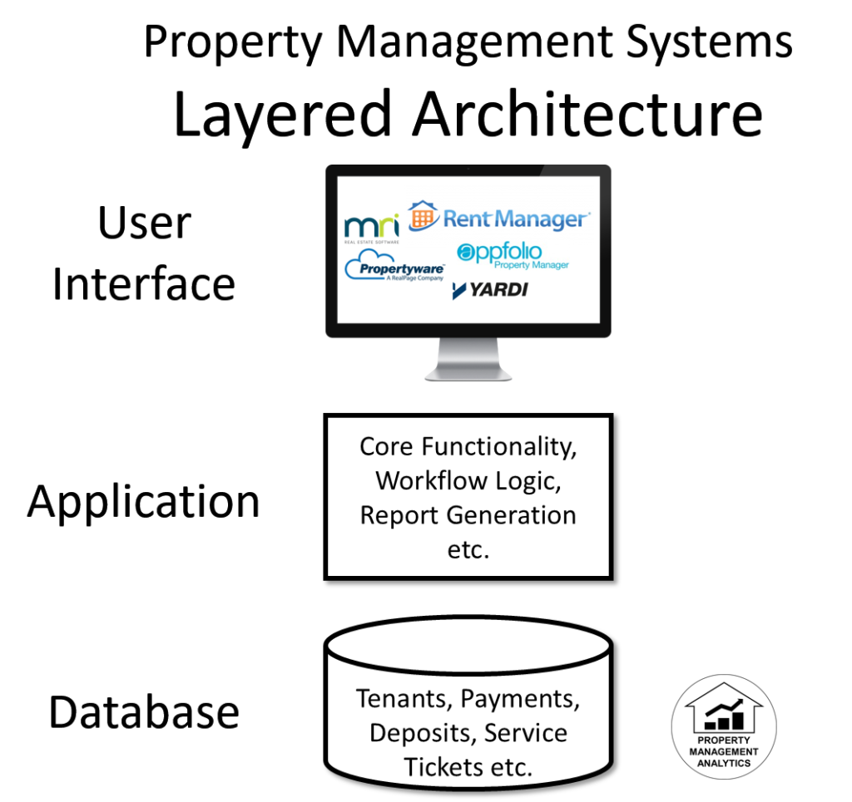

Figure 3.3: System Architecture

**3.6.3 Database Tables/Queries Structures**

## Table 3.1: Tenants Table

|  |  |  |  |  |
| --- | --- | --- | --- | --- |
| **Field** | **Datatype (length)** | **Null** | **Key** | **Extra** |
| id | int(10) | NO | PRIMARY | auto_increment |
| fullname | varchar(50) | YES |  |  |
| Mobile number | varchar(50) | YES |  |  |
| Status | Int(10) | YES | FOREIGN |  |
| Email | varchar(50) |  |  |  |
| House_id | int(10) |  |  |  |
| Date | timestamp |  |  |  |

#### Table 3.2: Houses Table

|  |  |  |  |  |  |
| --- | --- | --- | --- | --- | --- |
| **Field** | **Type** | **Null** | **Key** | **Default** | **Extra** |
| id | int(10) | NO | PRI |  | auto_increment |
| House_id | int(10) | YES |  |  |  |
| category | int(10) | YES |  |  |  |
| description | varchar(50) |  |  |  |  |
| Price | int(50) | YES |  | current_timestamp() |  |

#### Table 3.3: Payments Table

|  |  |  |  |
| --- | --- | --- | --- |
| **Field** | **Type** | **Key** | **Extra** |
| id | int(10) | PRI | auto_increment |
| Tenant_id | int(10) |  |  |
| amount | int(10) |  |  |
| invoice | varchar(50) |  |  |
| Date | timestamp |  |  |

#### Table 3.5: Users

|  |  |  |  |  |  |
| --- | --- | --- | --- | --- | --- |
| **Field** | **Type** | **Null** | **Key** | **Default** | **Extra** |
| id | int(10) | NO | PRI |  | auto_increment |
| Name | varchar(50) |  |  |  |  |
| username | varchar(50) | YES |  |  |  |
| password | varchar(100) | YES |  |  |  |
| Role | varchar(50) | YES |  |  |  |

**3.6.4 Database Entity Relationship Diagram**

This shows the relationship of the various tables in the database with each other

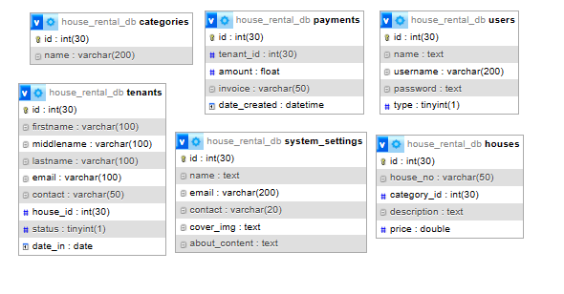

Figure 3.4: Database Entity Relationship Diagram

**3.6.5 Input and Output Design**

**LOGIN INTERFACE**

Enter Username

Enter Password

**Login**

Figure 3.5: Login interface

First name

Middle name

Last name

Gender

Date of Birth

**SIGN UP FORM**

Address:

Email:

House (Room)

Phone Number

Passport

**CANCEL**

**SAVE**

Figure 3.6: Sign Up Form

House number

Category

**NEW HOUSE**

Decription

Amount

SAVE

CANCEL

Figure 3.7: New House Interface

| **#** | **Date** | **Tenant** | **Invoice id** | **Amount** |
| --- | --- | --- | --- | --- |
| 1 | August 18, 2023 | HAFSAT AHMED | PXR-35023081722 | 75,000.00 |
| 2 | July 28, 2023 | ALIYU MUBARAK | PXR-350533781847 | 150,000.00 |
| 3 | July 18, 2023 | HAFSAT AHMED | ZYB-373884035733 | 75,000.00 |

Figure 3.8: Transactions Output Interface

| **#** | **House** | **Action** |
| --- | --- | --- |
| 1 | House #: **34**  House Type: **Multi-Family Home**  Description: **Students Size Room**  Price: **75,000.00** | Edit Delete |
| 2 | House #: **2**  House Type: **Multi-Family Home**  Description: **Students Size Room**  Price per month: 7**5,000.00** | Edit Delete |

Figure 3.9: Available House Output

**Name**

**User name**

**NEW USER**

**Password**

**User Type**

**SAVE**

**CANCEL**

Figure 3.10: Add User Interface

## 3.7 System Requirements Specification

**3.7.1 Hardware Requirements**

The software designed needed the following hardware for an effective operation of the newly designed system.

1. A system running on intel, P(R) duo core with higher processor
2. The-Random Access Memory (RAM) should be at least 512mb.
3. Enhanced keyboard.
4. At least 150GB hard disk.
5. V.G.A or a colored monitor.

**3.7.2 Software Requirements**

The software requirements include:

1. A window 7 or higher version of operating system.
2. XAMP or WAMP for Database
3. PHP

## 3.7.3 Personnel Requirements

Any computer literate who has a technical knowhow of internet surfing can use the system because it is user friendly.

# CHAPTER FOUR

# RESULTS AND DISCUSSION

## 4.1 Introduction

The new system is designed using PHP and MySQL programming language for easy records inserting and updating. This system will help in managing and easily retrieving of information from the system for management purposes. The new system Departmental Fee Payment system for the department of Computer Science is developed for the purpose of Departmental Fees payment in the department of computer Science Federal Polytechnic Mubi.

## 4.2 Results

**4.2.1 Welcome Interface**

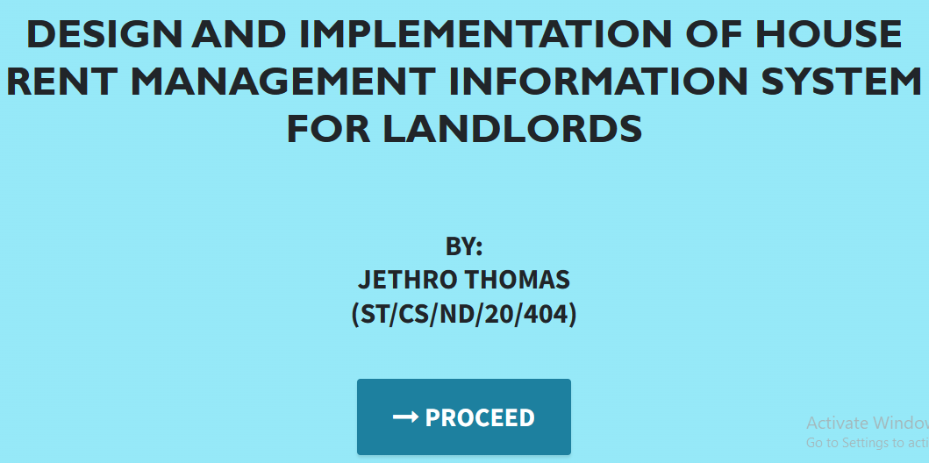

Figure 4.2.1: Welcome Interface

The above figure 4.2.1 shows the welcome page of the House Rent Management Information System, on the welcome page is the first page that displays the project topic.

**4.2.2 Login Interface**

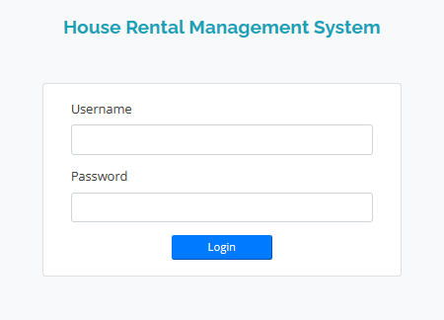

Figure 4.2.2: Login page interface

Figure 4.2.2 above shows the system login page interface. The login interface allows the Students and Administrator to enter his username and password to get access to the system.

**4.2.3 Tenant Registration**

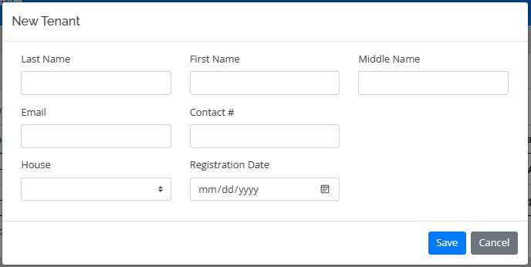

Figure 4.2.3: Tenant Registration Interface

Figure 4.2.3 above shows where the landlord can register tenants into the system using some basic information like the first name, lastname, contact, date, House.

**4.2.4 New House**

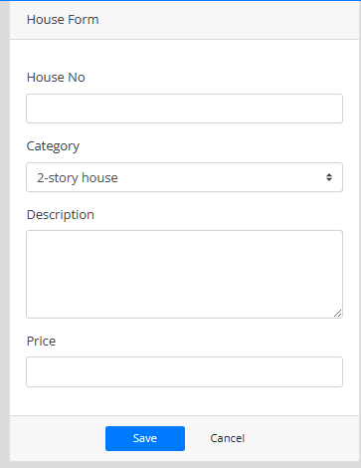

Figure 4.2.4: New House Interface

Figure 4.2.4 is used by the landlord to add a new house/room that is available into the system which will be allotted to a tenant upon registration.

**4.2.5 New User Interface**

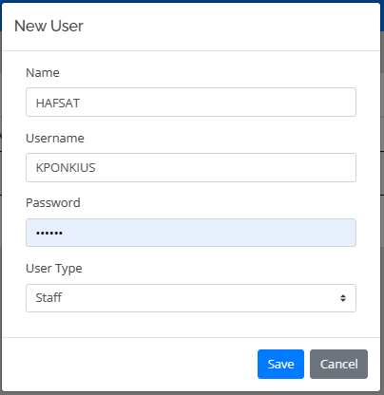

Figure 4.2.5: New User Interface

Figure 4.2.5 above is used to add a new user (admin) into the system who will also carry out task like the landlord

**4.2.6 Payment Invoice**

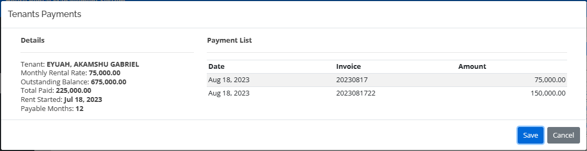

Figure 4.2.6: Payment Invoice

Figure 4.2.6 above is showing a payment receipt after successful payment has been made.

## 4.3 Discussion

The Welcome Interface is the initial landing page of the website. It is designed to create a positive first impression on visitors. This interface typically includes a visually appealing layout, branding elements, and possibly a brief introduction to the website's purpose or features. The goal is to engage users and encourage them to explore further.

The Login Interface is where registered users can log into their accounts using their credentials. It includes fields for entering a username/email and password. This interface may also include options for password recovery or account registration for new users who haven't signed up yet.

The Registration Interface allows the landlord to add new tenants into the system. Tenants typically provide their personal information, such as name, email, house. It may include validation checks to ensure the accuracy of provided data.

The "Add User" section is typically accessible to administrators or authorized staff members. It allows them to manage user accounts and grant access to the payment system. Key features and benefits include, User registration or creation of accounts staff members, User authentication and access control to ensure data security and privacy. Assigning roles and permissions to different user types.

The Dashboard Interface serves as a central hub where users can access key information and perform various tasks. It provides an overview of important data, metrics, and activities related to the user's role or responsibilities. Dashboards often include charts, graphs, notifications, and links to other sections of the website.

## 4.4 User manual

The following are the necessary steps to take in order to use the system efficiently and effectively.

1. Load the url of the system <https://localhost/house_rental/> the welcome page will be displayed.
2. Click on the **Proceed** button to proceed to the main system.
3. If you created an account, provide your login details by entering your username and password.
4. Depending on the login details provided you will be automatically directed to the dashboard.
5. The various task that you can perform on the portal will be displayed on the sidebar of the dashboard.

# CHAPTER FIVE

# SUMMARY, CONCLUSION AND RECOMMENDATIONS

## 5.1 Summary

This project presents the design and implementation of a comprehensive House Rent Management System tailored for landlords. The system aims to streamline and simplify the management of rental properties, offering a user-friendly interface for landlords to efficiently handle various aspects of their rental properties. The system encompasses tenant information management, rent tracking, maintenance scheduling, and financial record-keeping. By automating these tasks, the system helps landlords save time, enhance communication with tenants, and maintain accurate financial records.

## 5.2 Conclusion

In conclusion, the House Rent Management System offers an effective solution for landlords to manage their rental properties with ease. Through the implementation of this system, landlords can experience improved efficiency in tenant management, rent tracking, maintenance scheduling, and financial record-keeping. The user-friendly interface ensures accessibility and usability, even for those with limited technical knowledge. The successful implementation of the system demonstrates its potential to revolutionize the way landlords handle their rental properties.

## 5.3 Recommendations

Based on the implementation and usage of the House Rent Management System, several recommendations emerge:

1. Integration of Online Payment: Incorporate an online payment module to allow tenants to conveniently make rent payments through the system.
2. Mobile Application: Develop a mobile application version of the system to provide landlords with on-the-go access and notifications.
3. Data Analytics: Integrate data analytics features to provide landlords with insights into property performance, vacancy rates, and financial trends.
4. Tenant Portal: Create a portal for tenants to submit maintenance requests, communicate with the landlord, and access lease agreements.

## 5.4 Contribution to Knowledge

This project contributes to knowledge in the field of property management systems by presenting a tailored solution specifically designed for landlords. The system's features cater to the unique needs of landlords, focusing on simplified tenant management and financial tracking. The implementation process provides insights into the practical application of technology to enhance property management operations.

## 5.5 Area for Further Work

While the House Rent Management System offers a solid foundation for landlords to manage their rental properties, there are several avenues for further work:

Customization: Enhance the system's ability to be customized to the specific requirements of individual landlords and properties.

Scalability: Test the system's scalability to ensure smooth performance when managing a large number of properties and tenants.

Security: Conduct rigorous security audits and implement additional layers of security to protect sensitive tenant and financial data.

Market Integration: Explore integration with real estate marketplaces to facilitate property listing and tenant search functionalities.

Continued development and refinement in these areas will further elevate the effectiveness and versatility of the House Rent Management System.

# REFERENCES

AppFolio. (2021). *2021 Multifamily Predictions Report*. Retrieved from <https://www.appfolio.com/blog/2021-multifamily-predictions-report>

Avail. (2021). *The 2021 Landlord and Tenant Rental Market Report*. Retrieved from <https://www.avail.co/education/guides/2021-landlord-and-tenant-rental-market-report>

Babatunde, S., Iliya, S., Sanni, R., & Ogwueleka, F. (2021). Cloud Computing Adoption for Property Management Systems in the Real Estate Industry. *Journal of Systems and Information Technology,* 23(2), 289-308.

Bari, A. A., Zhang, Y., Yaseen, A., & Hwang, I. (2022). A Review of Data Analytics in Property Management. *In 2022 5th International Conference on Control, Automation and Robotics (ICCAR)*, 715-719.

Buildium. (2021). *2021 State of the Property Management Industry Report.* Retrieved from <https://www.buildium.com/resources/industry-reports/property-management-industry-report/>

Chen, J., & Huang, Z. (2021). Cloud-Based Property Management System with Mobile Integration for Small and Medium-Sized Landlords. *Journal of Systems and Information Technology*, 23(3), 486-503.

Daas, A., Messalem, R., Schäfer, J., & Steinmetz, R. (2021). Design and Development of Mobile Applications for Property Management. *International Journal of Information Systems and Project Management,* 9(2), 5-19.

Elmasri, R., & Navathe, S. B. (2019). *Fundamentals of Database Systems.* Pearson, New York.

Filho, H. R. S., Grillo, M. C. C., Oliveira, T. V. B., Santana, L. H., & Rodrigues, G. O. (2021). An Artificial Intelligence Platform for Property Management: *A Conceptual Model. Computers in Industry*, 125, 103-379.

Ghazal, A., Giceva, J., Idreos, S., & Pölitz, C. (2020). NoSQL and SQL Data Models: A Systematic Mapping Study. *ACM Computing Surveys*, 53(2), 1-38.

Ghosh, S., Rahman, M. M., Rana, N. P., Dwivedi, Y. K., & Talukder, S. (2021). The Role of Artificial Intelligence and Machine Learning in Real Estate: A Comprehensive Literature Review. *Information Technology & People,* 1-41.

Jagero, N., & Kangethe, S. (2020). Evaluation of Records Management Systems in Public Universities in Kenya. *International Journal of Information Systems and Project Management,* 8(3), 43-62.

Khan, M. I., & Al Ameen, M. (2021). The Adoption of Property Management Systems in the Real Estate Sector. *Journal of Business and Management*, 23(2), 71-92.

Kwon, I., & Lee, H. (2020). The Role of Management Information Systems in Data Analytics: A Strategic Perspective on Global Business Environments. *Information Systems Frontiers,* 22(4), 909-924.

Lee, S., Shin, J., & Jeong, J. (2020). Web-based Rental Property Management System for Efficient and Effective Property Management. *Journal of Engineering Technology*, 18(1), 221-229.

Letchkov, N., Koychev, I., & Ivanov, B. (2022). Cloud-Based Property Management Systems. *In Proceedings of the International Conference on Advances in Business, Management and Law* (pp. 169-177). Springer.

Liu, J., Cao, J., Zhang, J., & Xie, Y. (2021). Design and Implementation of Cloud-Based Record Management System for Universities. *Security and Communication Networks*, 2021, 665-883.

Mathe, N., Krotzsch, S., Lacroix, Z., & Lutters, W. (2021). Artificial Intelligence for Records Management: A Research Agenda. *In Proceedings of the 54th Hawaii International Conference on System Sciences.*

Motahari-Nezhad, H. R., Stephenson, B., Shahbazian, M., & Foster, H. (2021). Database Management Systems. *In Handbook on Securing Cyber-Physical Critical Infrastructure* (pp. 195-217). Springer.

NMHC. (2021). *NMHC Rent Payment Tracker Finds 79.4 Percent of Apartment Households Paid Rent as of June 6*. Retrieved from <https://www.nmhc.org/news/press-releases/nmhc-rent-payment-tracker-finds-79-4-percent-of-apartment-households-paid-rent-as-of-june-6/>

Oliveira, T., & Martins, M. F. (2021). The Role of Management Information Systems in Decision-Making and Communication Processes. *Telematics and Informatics*, 57, 101-554.

Osman, S., Al-Nabhan, N., Elhajj, I., & Chehab, A. (2020). Internet of Things for Real Estate Property Management: A Comprehensive Survey*. Journal of Network and Computer Applications*, 163, 102632

Oussaid, R., Khefifi, H., & Amghar, Y. (2021). Agile Methodologies in Property Management Systems: A Systematic Review. *International Journal of Software Engineering and Computer Systems,* 1(1), 24-33.

Rahman, M. M., Azam, M. N. H., & Sazzad, M. K. (2020). An Integrated Framework for E-Records Management System (ERMS) Development: A Study on Bangladesh Government Sector. *International Journal of Electronic Government Research*, 16(3), 19-38.

Ramakrishnan, R., & Gehrke, J. (2020). *Database Management Systems*. McGraw-Hill.

Rizvi, S., Khan, M. A., Bhatti, R. A., & Ziauddin, Z. (2021). A Comparative Study of Database Management Systems. *Journal of Information Systems and Technology Management*, 18, 202-1134.

Sarker, S., & Ali, A. S. (2020). Agile Software Development for Real Estate Management Systems: A Systematic Review. *IEEE Access*, 8, 21205-21220.

Shen, Y., He, X., & Fan, W. (2021). Mobile Property Management Systems: A Study of Design and Implementation. *Information Systems Frontiers*, 1-14.

Singhal, P., Sharma, S., & Srinivasan, A. (2021). Record Management System: A Boon for Organizational Efficiency. *In International Conference on Information Management and Machine Intelligence* (pp. 29-38). Springer.

Statista. (2021). *Property Management Software Market Size Worldwide from 2019 to 2025*. Retrieved from <https://www.statista.com/statistics/1174703/property-management-software-market-size-worldwide/>

Turban, E., Sharda, R., & Delen, D. (2021). *Business Intelligence and Analytics: Systems for Decision Support*. Pearson Education.

Wu, S., & Zhu, X. (2021). An Empirical Study of the Application of Management Information Systems in Organizations. *Journal of Systems Science and Information*, 9(1), 98-109.

Yang, S., Zuo, M., & Hu, Q. (2020). A Framework for Smart Rental Property Management. *IEEE Access*, 8, 134127-134139.

Yau, T. W., Yiu, K. T., & Leung, S. W. (2021). Enhancing the Tenant-Management Communication Process through Mobile Technology in Residential Property Management. *Journal of Real Estate Research,* 43(1), 49-78.

Zhang, J., Li, S., Yang, W., & Wang, X. (2020). Big Data Analytics in Property Management: *A Review. Smart Cities*, 3(4), 974-991.

Zillow. (2021). *Zillow Group Consumer Housing Trends Report 2021*. Retrieved from <https://www.zillow.com/report/2021/consumer-housing-trends/>

# APPENDIX A

Welcome interface



Login Interface



Tenant Registration



New House



New User Interface



Payment Invoice



# APPENDIX B

**PROGRAM CODE**

<!DOCTYPE html>

<html lang="en">

<head>

  <meta charset="utf-8">

  <meta content="width=device-width, initial-scale=1.0" name="viewport">

  <title>House Rental Management System</title>

<meta content="" name="descriptison">

  <meta content="" name="keywords">

  <!-- Google Fonts -->

  <link href="https://fonts.googleapis.com/css?family=Open+Sans:300,300i,400,400i,600,600i,700,700i|Raleway:300,300i,400,400i,500,500i,600,600i,700,700i|Poppins:300,300i,400,400i,500,500i,600,600i,700,700i" rel="stylesheet">

    <link rel="stylesheet" href="assets/font-awesome/css/all.min.css">

  <!-- Vendor CSS Files -->

  <link href="assets/vendor/bootstrap/css/bootstrap.min.css" rel="stylesheet">

  <link href="assets/vendor/icofont/icofont.min.css" rel="stylesheet">

  <link href="assets/vendor/boxicons/css/boxicons.min.css" rel="stylesheet">

  <link href="assets/vendor/venobox/venobox.css" rel="stylesheet">

  <link href="assets/vendor/animate.css/animate.min.css" rel="stylesheet">

  <link href="assets/vendor/remixicon/remixicon.css" rel="stylesheet">

  <link href="assets/vendor/owl.carousel/assets/owl.carousel.min.css" rel="stylesheet">

  <link href="assets/vendor/bootstrap-datepicker/css/bootstrap-datepicker.min.css" rel="stylesheet">

  <link href="assets/DataTables/datatables.min.css" rel="stylesheet">

  <link href="assets/css/jquery.datetimepicker.min.css" rel="stylesheet">

  <link href="assets/css/select2.min.css" rel="stylesheet">

  <!-- Template Main CSS File -->

  <link href="assets/css/style.css" rel="stylesheet">

  <link type="text/css" rel="stylesheet" href="assets/css/jquery-te-1.4.0.css">

  <script src="assets/vendor/jquery/jquery.min.js"></script>

  <script src="assets/DataTables/datatables.min.js"></script>

  <script src="assets/vendor/bootstrap/js/bootstrap.bundle.min.js"></script>

  <script src="assets/vendor/jquery.easing/jquery.easing.min.js"></script>

  <script src="assets/vendor/php-email-form/validate.js"></script>

  <script src="assets/vendor/venobox/venobox.min.js"></script>

  <script src="assets/vendor/waypoints/jquery.waypoints.min.js"></script>

  <script src="assets/vendor/counterup/counterup.min.js"></script>

  <script src="assets/vendor/owl.carousel/owl.carousel.min.js"></script>

  <script src="assets/vendor/bootstrap-datepicker/js/bootstrap-datepicker.min.js"></script>

    <script type="text/javascript" src="assets/js/select2.min.js"></script>

    <script type="text/javascript" src="assets/js/jquery.datetimepicker.full.min.js"></script>

    <script type="text/javascript" src="assets/font-awesome/js/all.min.js"></script>

  <script type="text/javascript" src="assets/js/jquery-te-1.4.0.min.js" charset="utf-8"></script>

</head>

<style>

  body{

    width: 100%;

      height: calc(100%);

      /*background: #007bff;*/

  }

  main#main{

    width:100%;

    height: calc(100%);

    background:white;

  }

  #login-right{

    position: absolute;

    right:0;

    width:40%;

    height: calc(100%);

    background:white;

    display: flex;

    align-items: center;

  }

  #login-left{

    position: absolute;

    left:0;

    width:60%;

    height: calc(100%);

    background:#59b6ec61;

    display: flex;

    align-items: center;

    /*background: url(assets/uploads/blood-cells.jpg);

      background-repeat: no-repeat;

      background-size: cover;*/

  }

  #login-right .card{

    margin: auto;

    z-index: 1

  }

  .logo {

    margin: auto;

    font-size: 8rem;

    background: white;

    padding: .5em 0.7em;

    border-radius: 50% 50%;

    color: #000000b3;

    z-index: 10;

}

div#login-right::before {

    content: "";

    position: absolute;

    top: 0;

    left: 0;

    width: calc(100%);

    height: calc(100%);

    /*background: #000000e0;*/

}

</style>

<body>

  <main id="main" class=" bg-light">

      <div id="login-left" class="bg-info">

        <img src="house.png" alt="..." width="100%">

      </div>

      <div id="login-right" class="bg-light">

        <div class="w-100">

      <h4 class="text-info text-center"><b>House Rental Management System</b></h4>

      <br>

      <br>

        <div class="card col-md-8">

          <div class="card-body">

            <form id="login-form" >

              <div class="form-group">

                <label for="username" class="control-label">Username</label>

                <input type="text" id="username" name="username" class="form-control">

              </div>

              <div class="form-group">

                <label for="password" class="control-label">Password</label>

                <input type="password" id="password" name="password" class="form-control">

              </div>

              <center><button class="btn-sm btn-block btn-wave col-md-4 btn-primary">Login</button></center>

            </form>

          </div>

        </div>

        </div>

      </div>

  </main>

  <a href="#" class="back-to-top"><i class="icofont-simple-up"></i></a>

</body>

<script>

  $('#login-form').submit(function(e){

    e.preventDefault()

    $('#login-form button[type="button"]').attr('disabled',true).html('Logging in...');

    if($(this).find('.alert-danger').length > 0 )

      $(this).find('.alert-danger').remove();

    $.ajax({

      url:'ajax.php?action=login',

      method:'POST',

      data:$(this).serialize(),

      error:err=>{

        console.log(err)

    $('#login-form button[type="button"]').removeAttr('disabled').html('Login');

      },

      success:function(resp){

        if(resp == 1){

          location.href ='index.php?page=home';

        }else{

          $('#login-form').prepend('<div class="alert alert-danger">Username or password is incorrect.</div>')

          $('#login-form button[type="button"]').removeAttr('disabled').html('Login');

        }

      }

    })

  })

</script>

</html>